
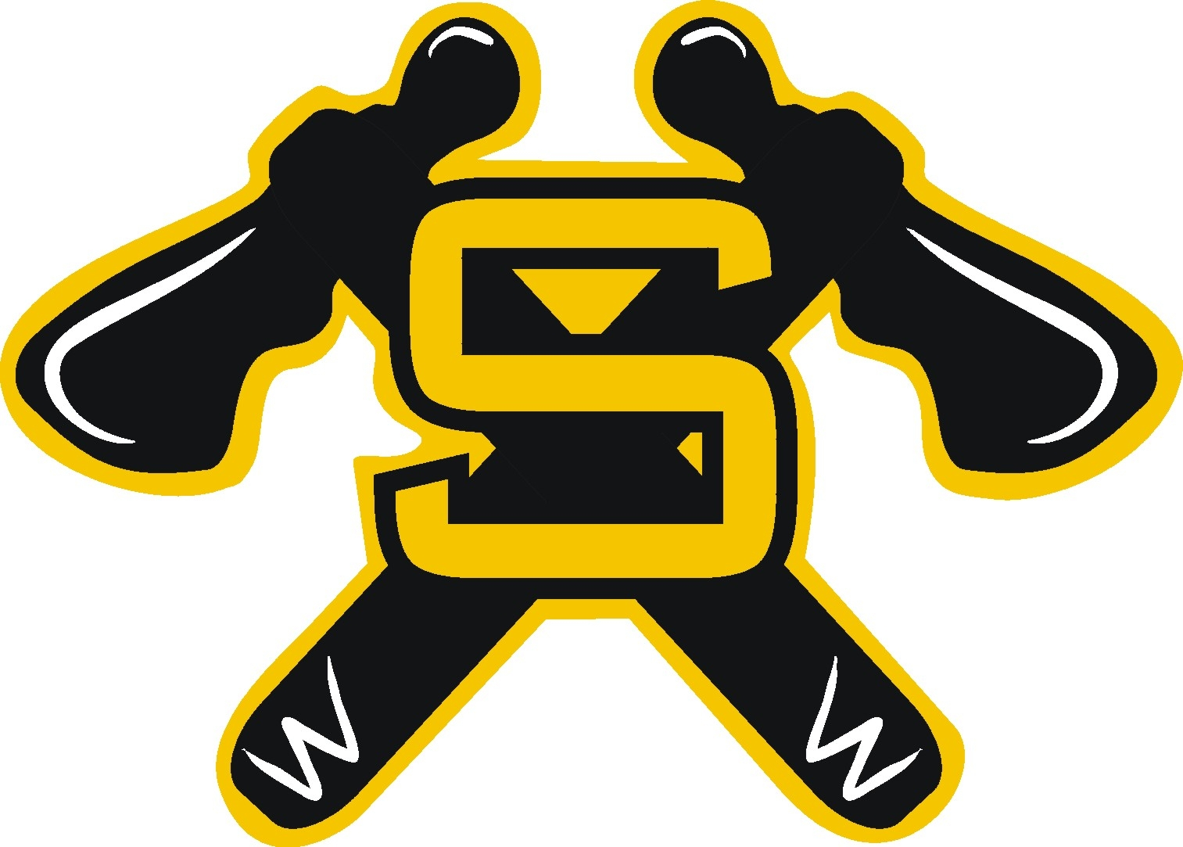
STRATHCONA MINOR HOCKEY ASSOCIATION
P.O. Box 29, Ardrossan, AB, T8E 2A1
Website: smhahockey.org

September 29, 2016

Dear Sir/Madam:

Re: Strathcona (team name)

This letter will confirm that I (First and Last name), (Team Treasurer) and (First and Last Name), (Team Manager) are members of The Strathcona Minor Hockey Association and represent the above mentioned team. They are permitted to open a bank account on behalf of the Strathcona (Team Name) hockey team. It is agreed that both of these persons must sign for this account.

Yours truly,

(First and Last Name)
Head Coach
Strathcona Minor Hockey Association

